

《软件工程原理与应用》
系统设计报告
体育场馆预约系统
小 组 | 103 F 官宇 鱼水 杨志豪
学院 | 计算机科学与技术学院/软件学院
专业 | 计算机科学与技术
班级 | 1623103

二〇二五年十一月

目 录
一、引言 3
1、编写目的 3
2、背景 3
3、 定义 3
4、参考文献 4
二、界面设计 4
1、OrdinaryUser类 4
2、Administrator类 10
3、StadiumAdministrator类 12
4、Stadium类 13
5、Field类 15
6、Reservation类 17
7、Comment类 18
8、 Period类 20
三、事务逻辑设计 21
1、OrdinaryUser类 21
2、Administrator类 27
3、StadiumAdministrator类 29
4、 Stadium类 35
5、 Field类 38
6、 Reservation类 40
7、 Comment类 42
8、 Period类 44
四、数据库设计 46
1、 User类 46
2、 OrdinaryUser类 46
3、 Administrator类 46
4、 StadiumAdministrator类 47
5、 Stadium类 47
6、 Field类 47
7、 Period类 47
8、 reservation类 48
9、 Comment类 48

一、引言

1、编写目的
需求说明书目的是使用户和软件开发者双方对该软件有一个共同的理解，使之成为整个开发工作的基础。便于用户、开发人员进行理解和交流，反映出用户问题的结构，可以作为软件开发工作的基础和依据，并作为确认测试和验收的依据。
预期读者：软件设计者和测试者。

2、背景
说明：
- 待开发的软件系统的名称：体育场馆预约系统
- 本项目的任务提出者：官宇 鱼水 杨志豪；
- 本项目的任务开发者：官宇 鱼水 杨志豪；
- 用户：所有需要预约体育场馆的民众；
- 实现该软件的计算中心或计算机网络：南京航空航天大学计算中心。

定义
名称 | 说明
账号 | 用户注册时登记的用户名（或手机）及密码
用户分类 | 用户、管理员
账户信息管理 | 用户与管理员都可通过该模块对自己的信息进行增加、查询、修改、删除操作，分别对应注册、登录、修改用户信息及找回密码、注销，管理员拥有对所有用户的信息进行各项操作的权限
发布场馆信息 | 场馆管理员填写需要发布的场馆信息后送审
修改场馆信息 | 场馆管理员修改场馆信息后送审
查看场馆信息 | 所有用户均可查看已发布的场馆信息，并通过场馆名称查询特定场馆信息
审核场馆信息 | 系统管理员审核用户发布的场馆信息，可以选择通过或退回
删除场馆信息 | 场馆管理员可以删除场馆信息
发布场地信息 | 场馆管理员按要求在已发布的场馆中添加新的场地
修改场地信息 | 场馆管理员修改场地信息后送审
查看场地信息 | 所有用户均可查看已发布的场地信息
删除场地信息 | 场馆管理员可以删除具体场地
提交场地预约信息 | 普通用户提交申请，预约体育场地
审核场地预约信息 | 场馆管理员可审核用户提交的预约申请，可以选择通过或退回
取消场地预约 | 普通用户可取消自己已提交的场地预约申请
查看场地预约信息 | 普通用户可以查看已提交的场地预约申请
发表评论 | 普通用户可以在相关场馆评论区下发表评论
查看评论 | 普通用户查看其他人或自己发布过的评论
审核评论 | 系统管理员审核用户发表的评论，可以选择通过或退回
删除评论 | 发布该评论的普通用户或系统管理员可以删除评论

4、参考文献
编号 | 参考资料 | 作者
1 | 《软件工程（第四版）》，高等教育出版社，2019 | 齐治昌等
2 | 《构建之法（第二版）》，人民邮电出版社，2015 | 邹欣
3 | 《Test-Driven Development with Python》，O'Reilly，2014 | Harry J. W

二、界面设计

1、OrdinaryUser类
signupOrdinaryUser.html | 普通用户注册页面
web：
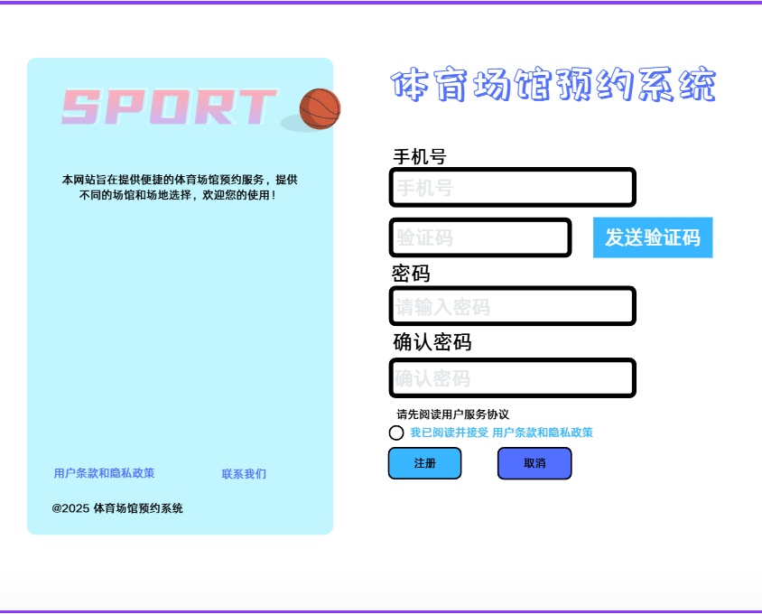
app:

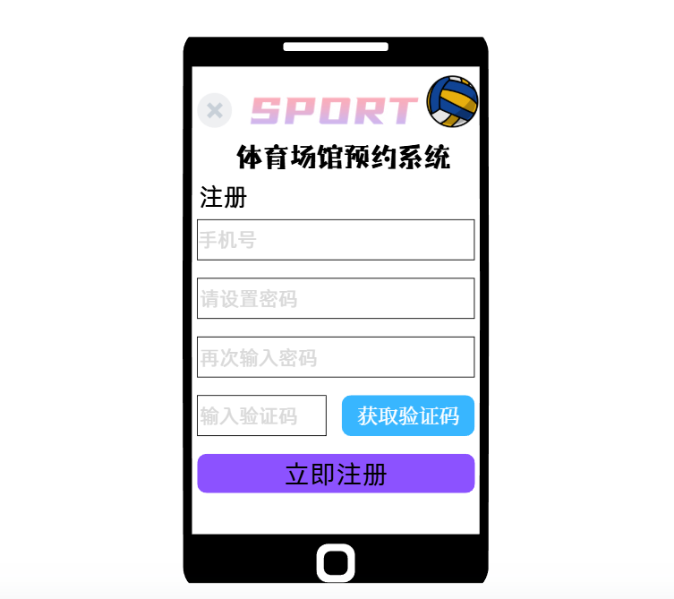
signin.html | 登录页面
web:
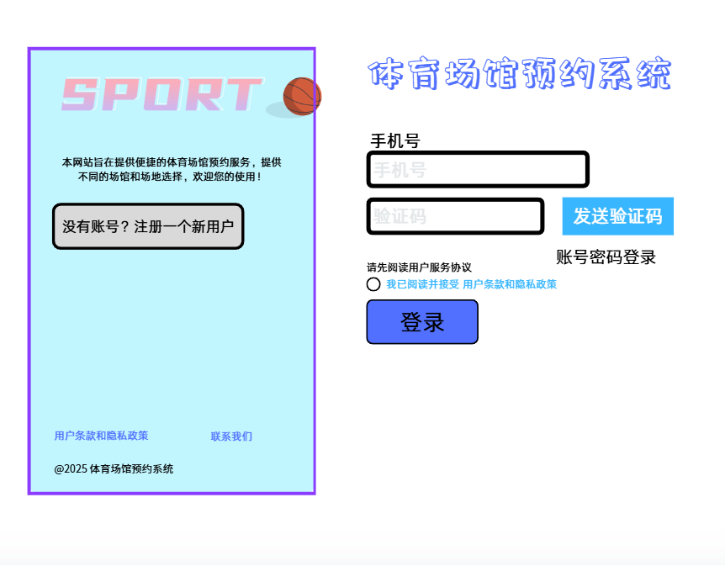
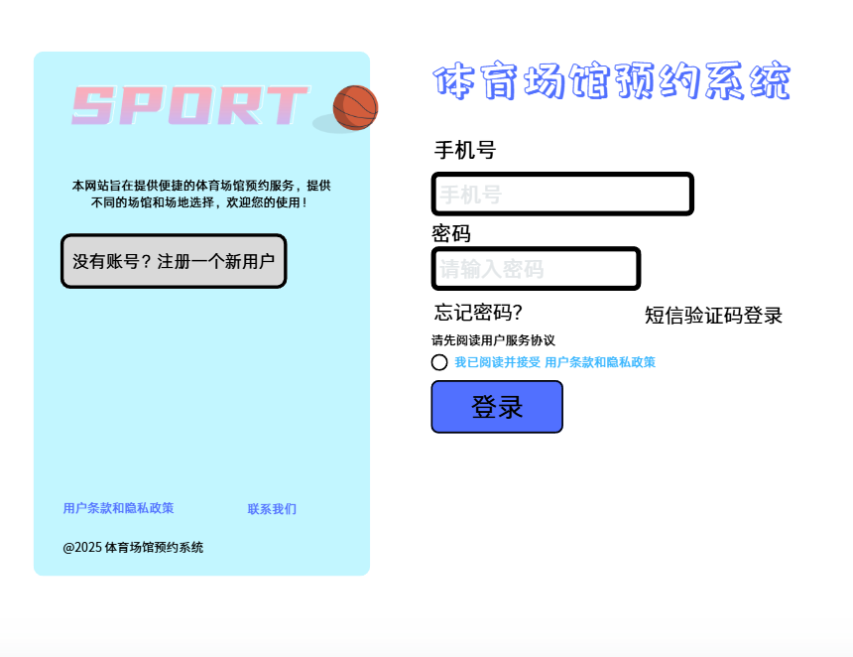
app:

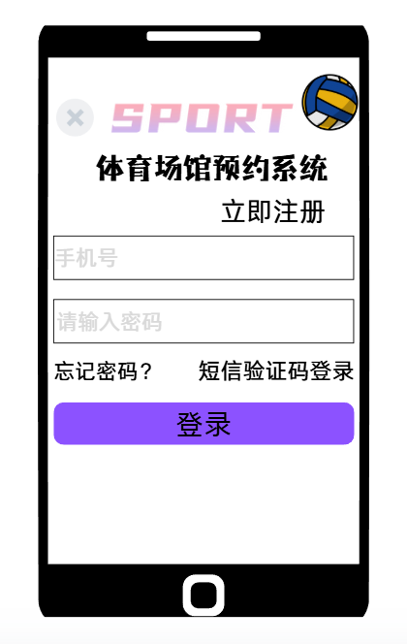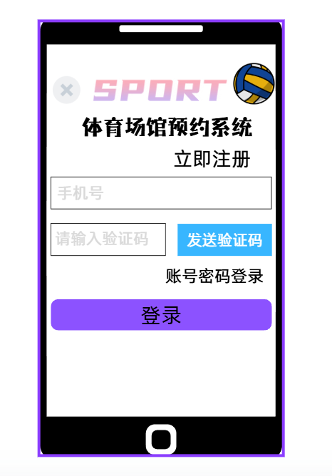
index.html | 首页
web:
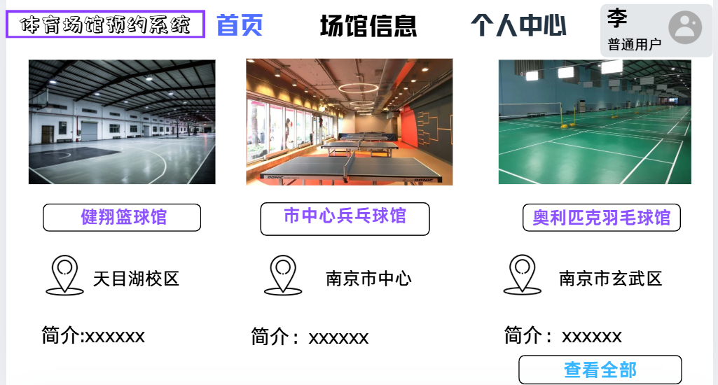
getUserInfo.html | 查看个人信息页面
changeUserInfo.html | 修改个人信息界面
changePassword.html | 修改密码
cancelUser.html | 注销账户页面
forgetPassword.html | 密码找回页面
web:
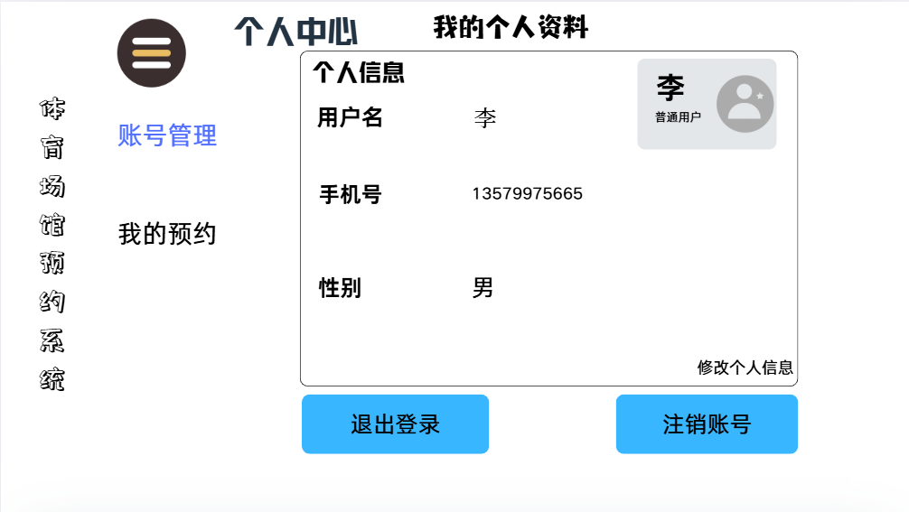
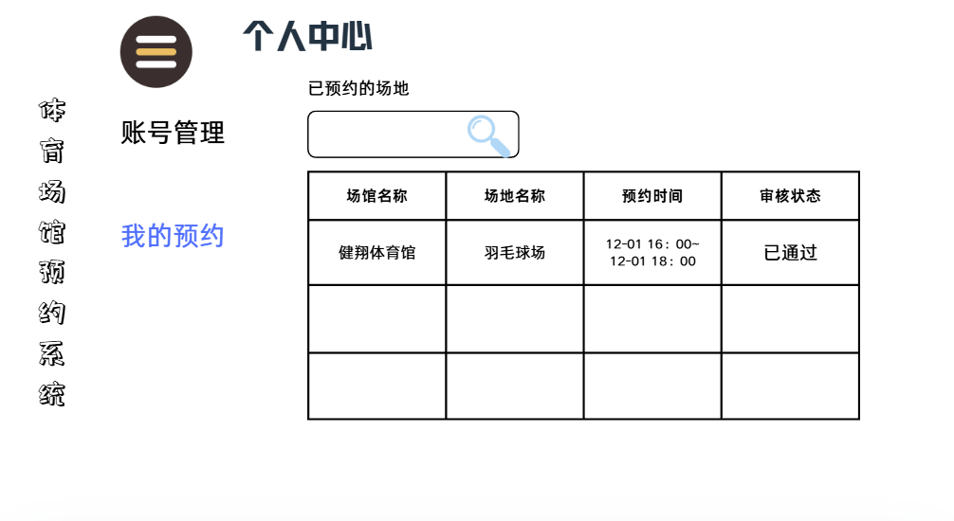
app:

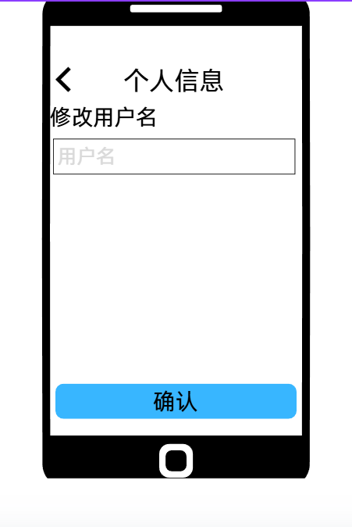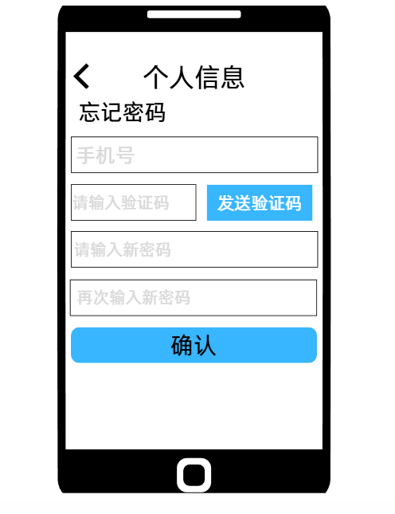
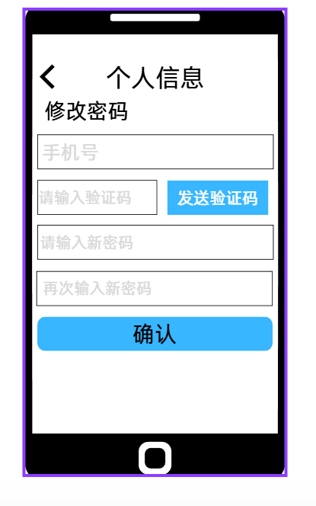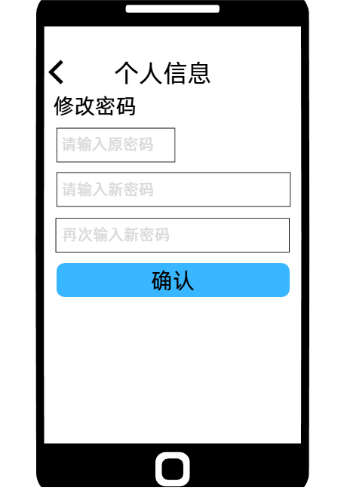

2、Administrator类
manageUser.html | 管理用户账号页面
web:
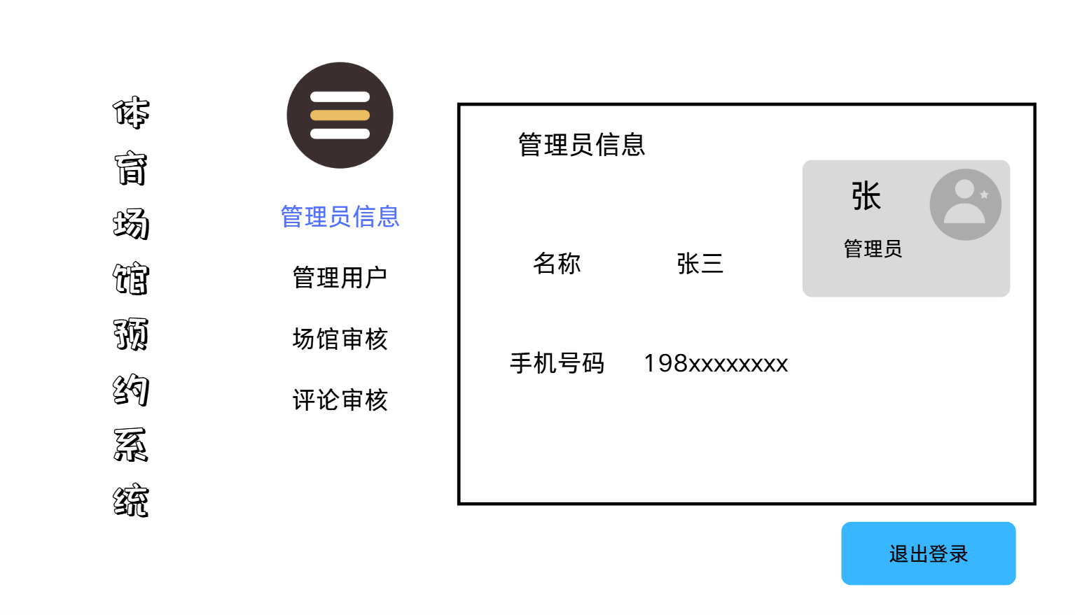
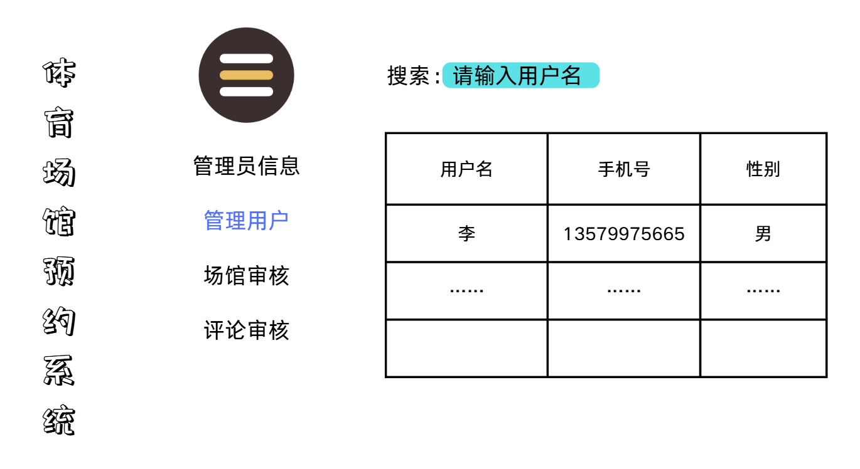
resultSearchUser.html | 查询用户结果页面
web:
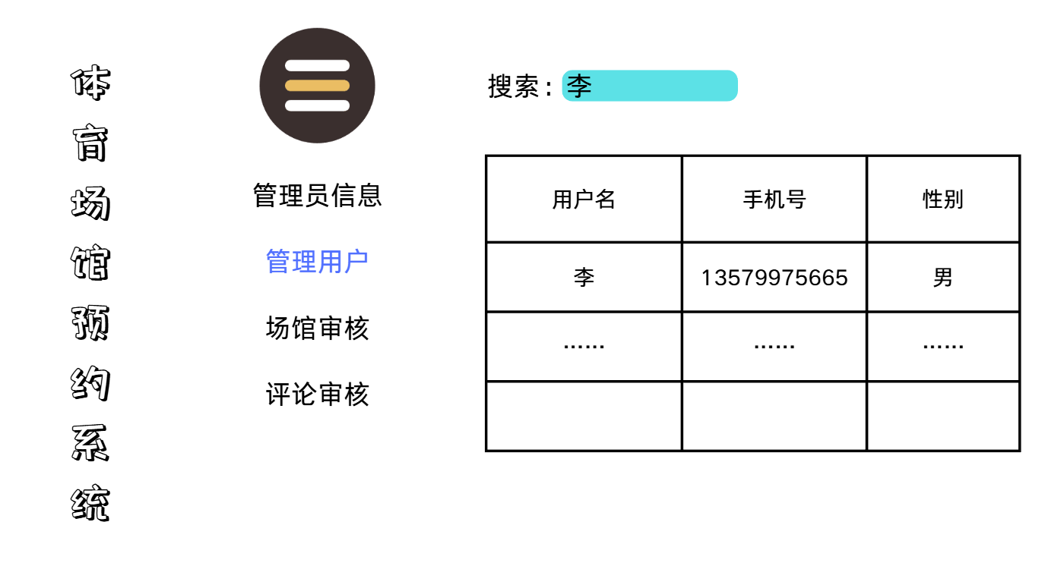

auditStadium.html | 审核体育场馆页面
web:
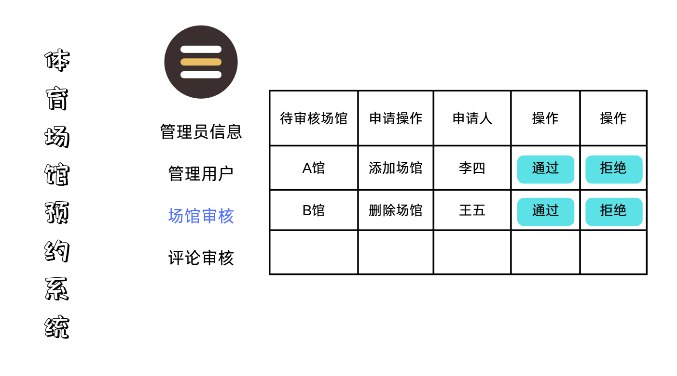
auditComment.html | 审核评论页面
web:

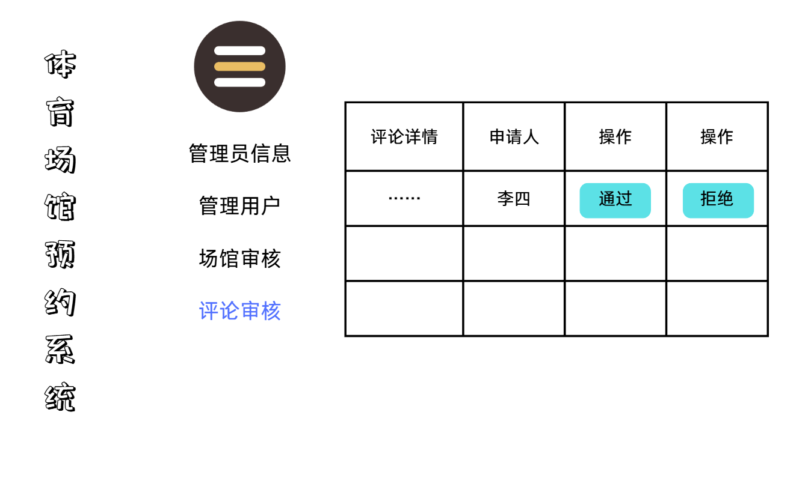

3、StadiumAdministrator类
manageFields.html | 管理场馆页面
auditReservation.html | 审核预约页面
web:
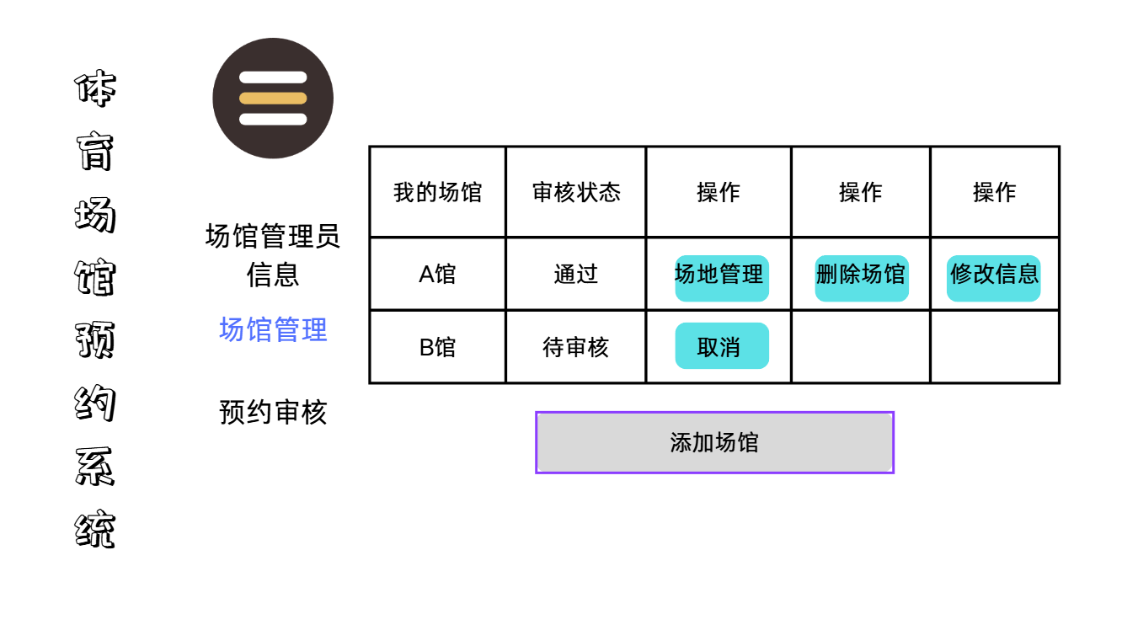
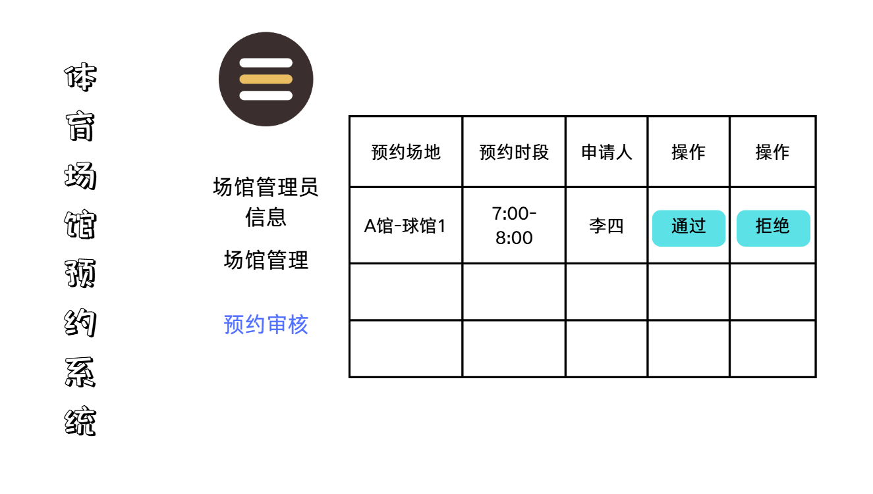

4、Stadium类
ManageStadium.html | 管理体育场馆界面
web:

DisplayStadium.html | 体育场馆详情界面
web:
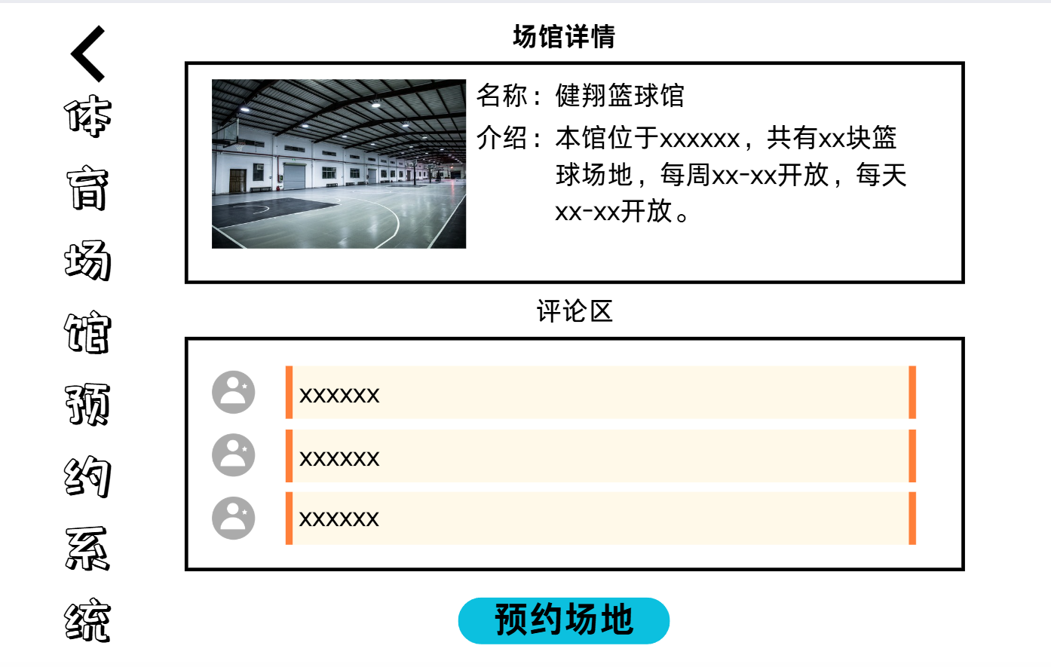
AddStadium.html | 发布体育场馆页面
web:
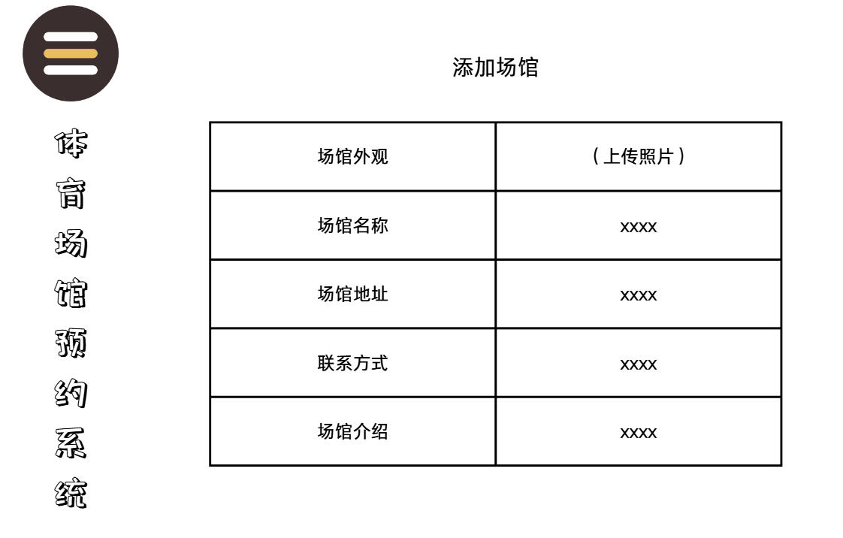

SearchStadium.html | 查询体育场馆页面
web:
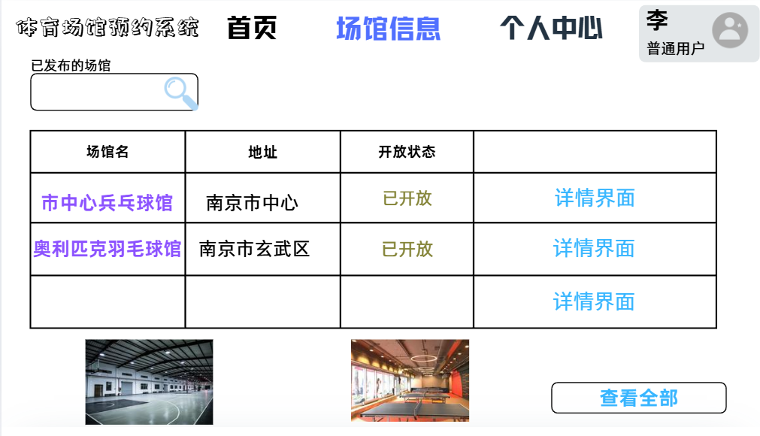

EditStadium.html | 编辑场馆信息页面

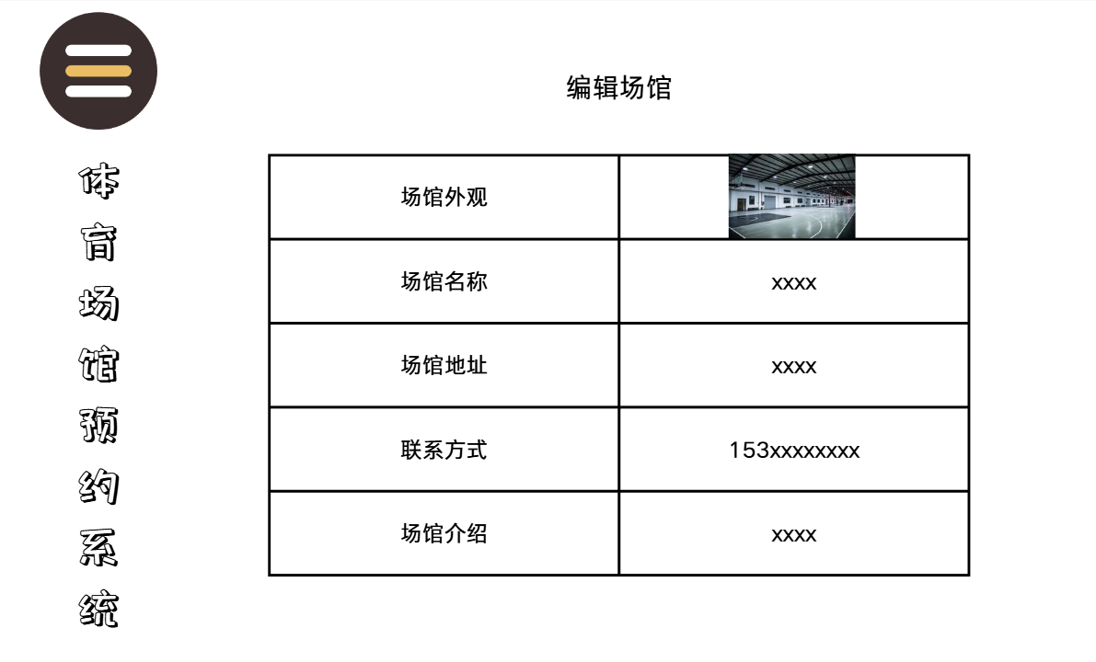

5、Field类
AddField.html | 体育场地发布页面

web:
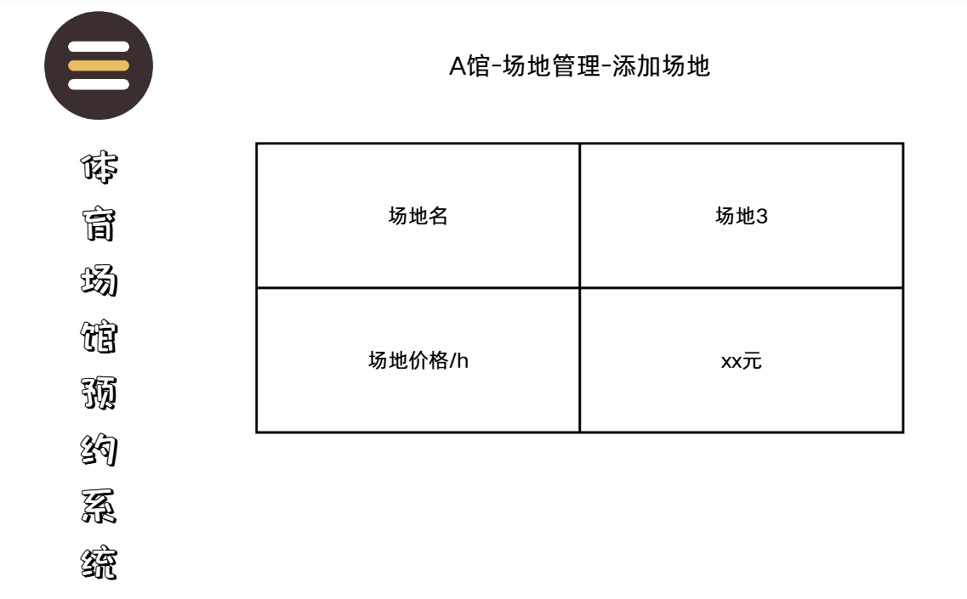
ManageField.html | 管理体育场地页面
web:
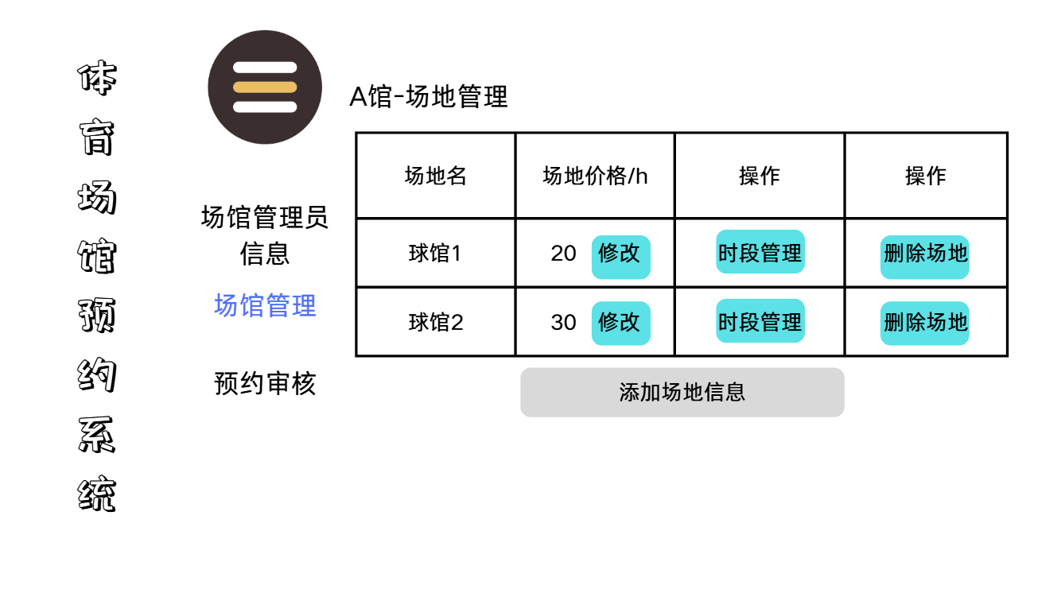
DisplayField.html | 体育场地详情页面
web:
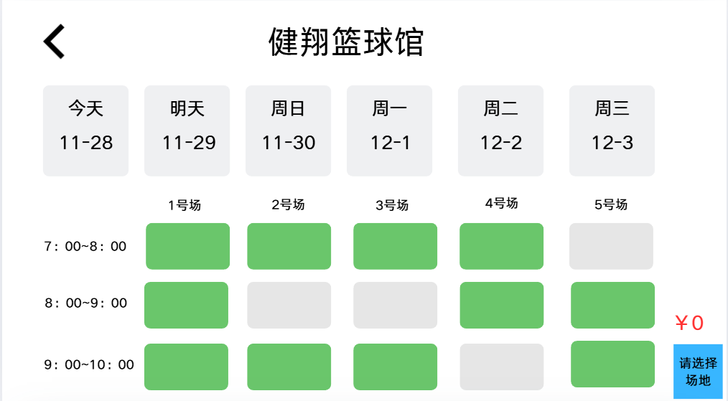

6、Reservation类
AddReservation.html | 提交预约页面
DeleteReservation.html | 取消预约页面
ManageReservation.html | 管理预约页面
SearchReservation.html | 查询预约页面
DisplayReservation.html | 预约详情页面
web:
用户管理预约：
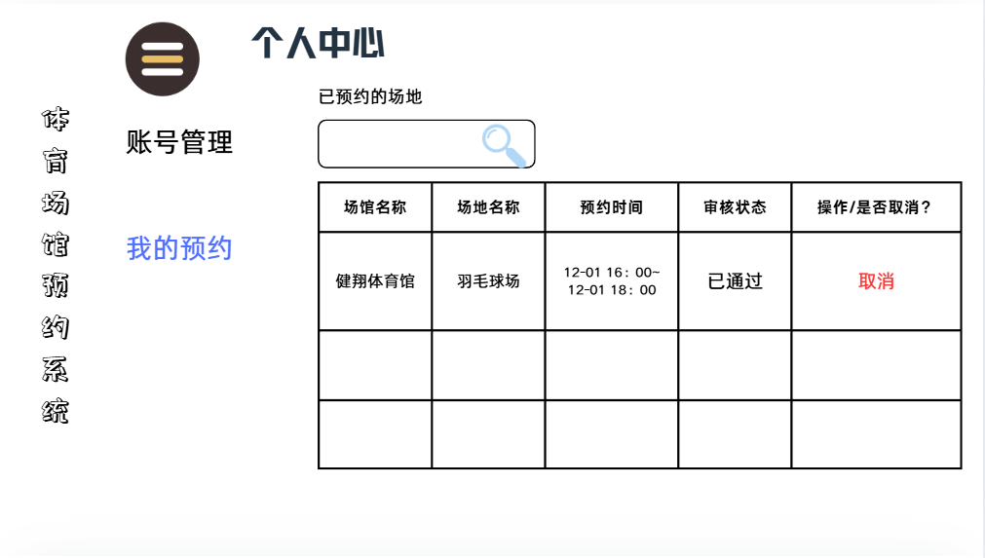
场馆管理员管理预约：


7、Comment类
AddComment.html | 发布评论页面
SearchComment.html | 查询评论页面
EditComment.html | 编辑评论页面
DisplayComment.html | 评论详情页面
DeleteComment.html | 删除评论页面
web:
普通用户发表、删除评论：
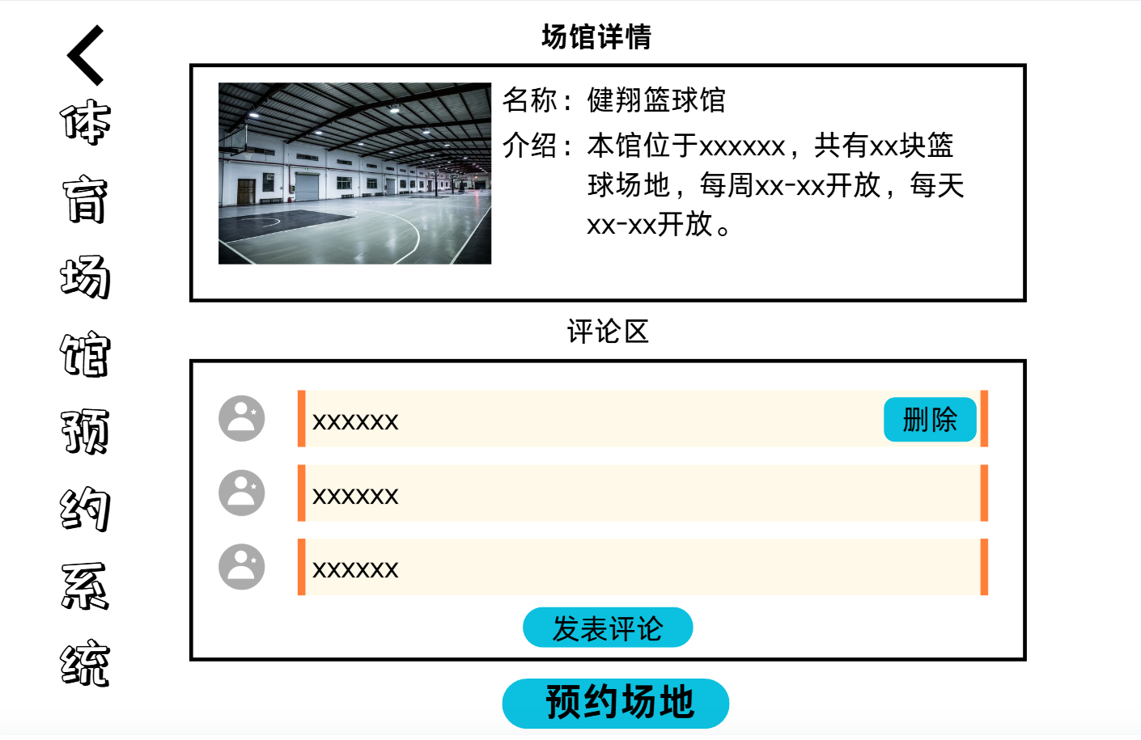
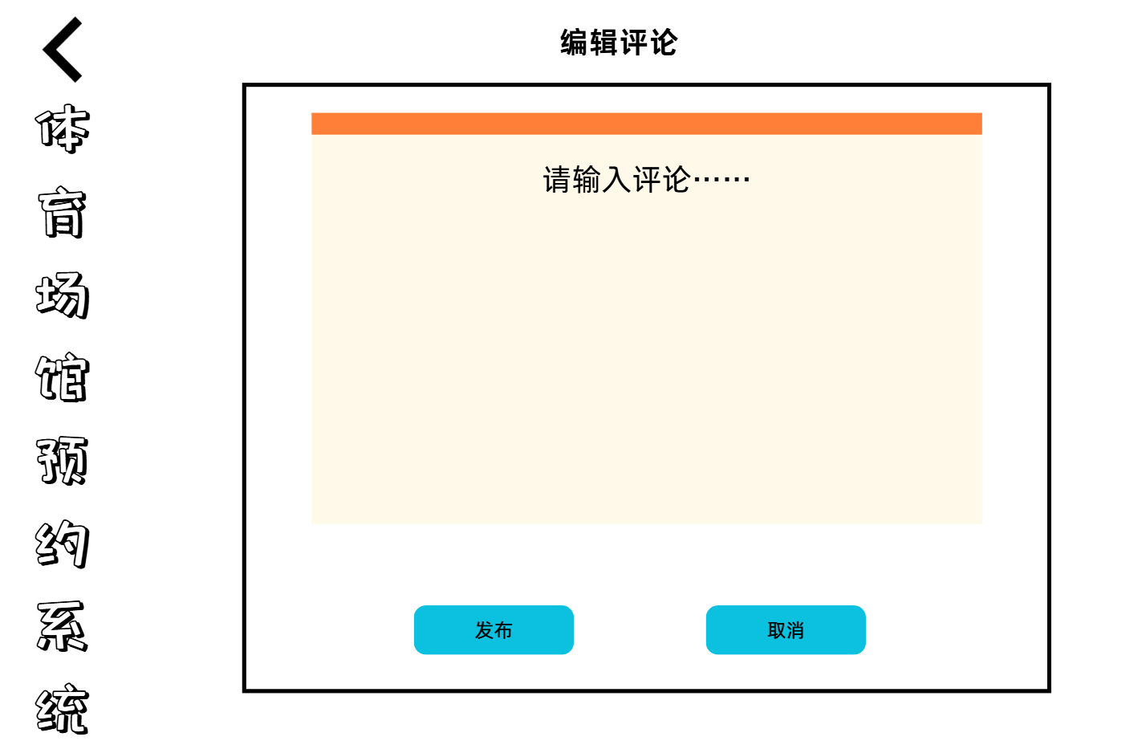

管理员删除任意评论：
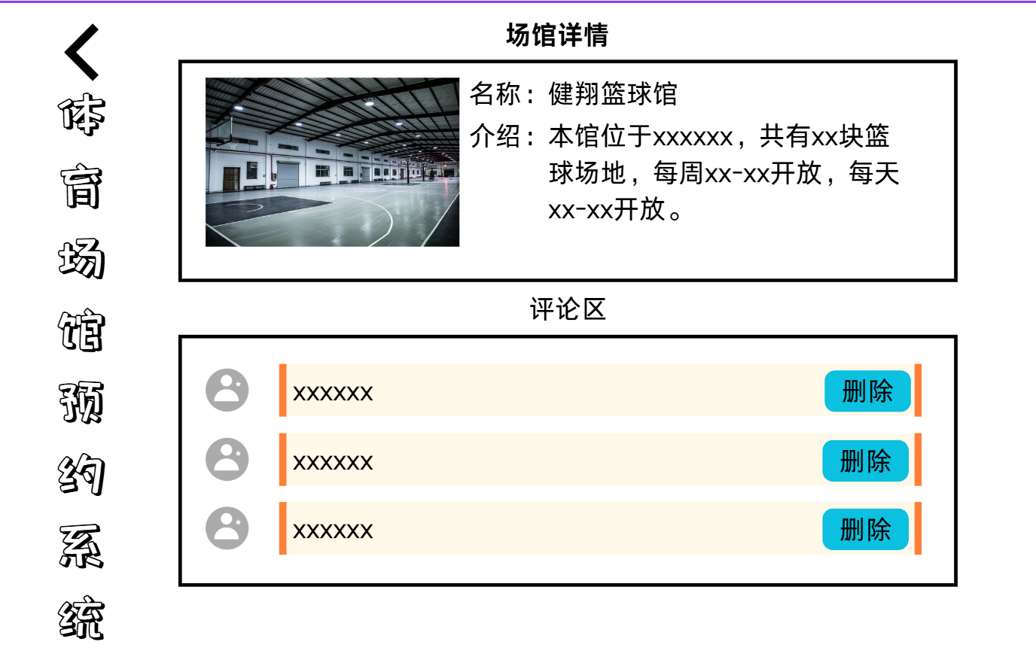

Period类
AddPeriod.html | 新增时段页面
ChangePeriod.html | 修改时段页面
DeletePeriod.html | 删除时段页面
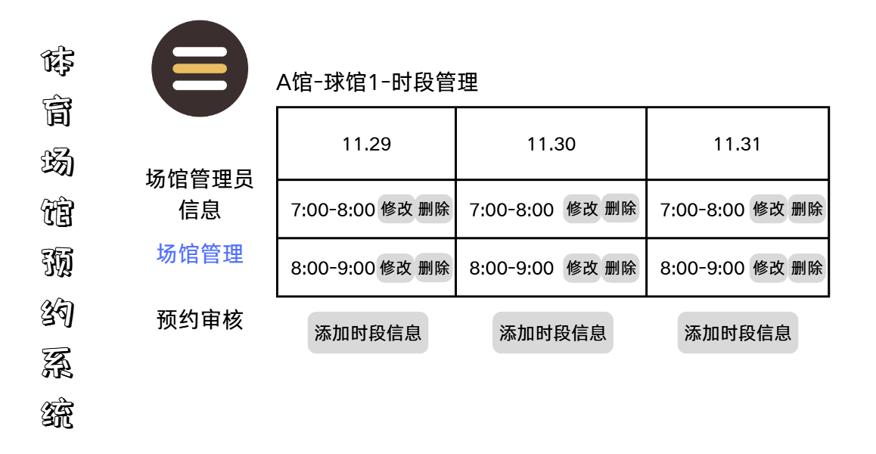
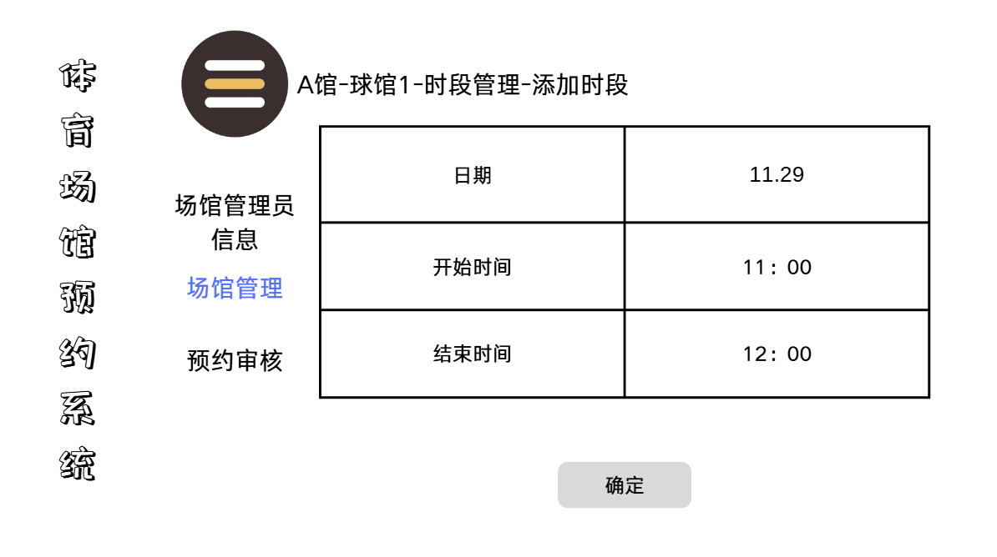
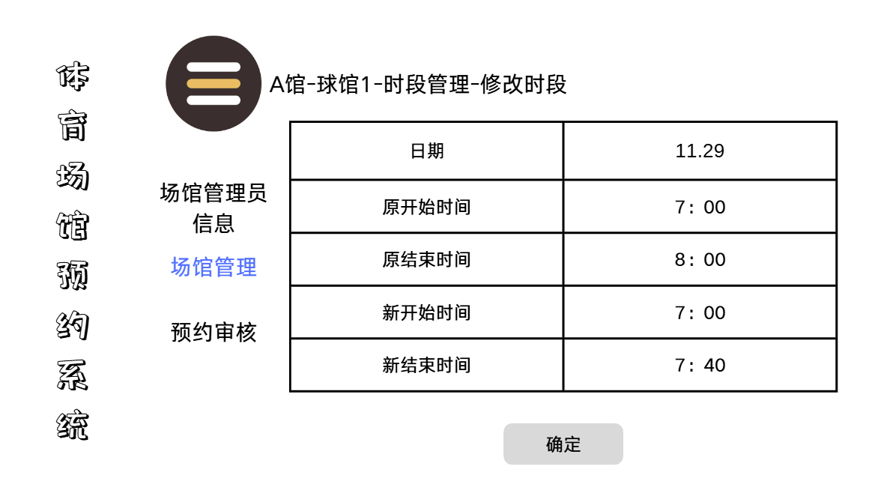

三、事务逻辑设计

1、OrdinaryUser类
登录处理
Procedure login
Begin
choose the method of login
If (choose password login) then
get the user's phonenumber and userPassword from signin.html
find the phonenumber and corresponding password in the database
If (phonenumber not found) or (phonenumber exists but inputPassWord != Password in database) then
display error hint
Else
goto index.html
End if
Else if (choose verification code login) then
get the user's phonenumber and verification code from signin.html
find the phonenumber in the database and verify the verification code
If (phonenumber not found) or (verification code is incorrect) then
display error hint
Else
goto index.html
End if
End if
End login

注册处理
Procedure signup
Begin
get the new_user's phonenumber, two passwords from signup.html
find the phonenumber in the database
If (phonenumber exists) or (phonenumber format is incorrect) then
display error hint
Else
check if the two passwords are consistent
If (passwords are inconsistent) then
display error hint
Else
send verification code to the phonenumber
get and check the verification code from signup.html
If (verification code is incorrect) then
display error hint
Else
add user's info to database
goto signin.html
End if
End if
End if
End signup

修改个人信息处理
Procedure changeUserInfo
Begin
choose the information to modify (nickname or password)
If (choose nickname) then
input new nickname
save and submit
update the nickname in the database
display success hint
Else if (choose password) then
choose verification method
If (choose original password verification) then
input original password
find the user's password in the database and compare
If (original password != password in database) then
display error hint
Else
input new password
check the new password format
If (new password format is incorrect) then
display error hint
Else
input new password again
If (the two new passwords are inconsistent) then
display error hint
Else
update the password in the database
display success hint
End if
End if
End if
Else if (choose verification code verification) then
send verification code to the phonenumber
input verification code
check the verification code
If (verification code is incorrect) then
display error hint
Else
input new password
check the new password format
If (new password format is incorrect) then
display error hint
Else
input new password again
If (the two new passwords are inconsistent) then
display error hint
Else
update the password in the database
End if
End if
End if
End if
End if
goto getUserInfo.html
End changeUserInfo

忘记密码重置密码处理
Procedure forgetpassword
Begin
get the user's phonenumber from forgetpassword.html
find the user's phonenumber in the database
If (the user's phonenumber is not existed) then
display error hint
Else
send the verification to the user
get and check the verification from forgetpassword.html
If (the verification is not correct) then
display error hint
Else
get two new_password which is inputted by the user twice
check if the new password format is correct
If (new password format is incorrect) then
display error hint
Else if (the two new_password is the same) then
find the user's info in the database
change the old_password into the new_password
goto signin.html
Else
display error hint
End if
End if
End if
End forgetpassword

注销账号处理
Procedure cancelUser
Begin
get the user's information from getUserInfo.html
choose verification method
If (choose password verification) then
input password and check
If (password is incorrect) then
display error hint
Else
confirm cancellation
If (confirm == true) then
find the user in database
cancel the user's account and set the account as non-existent in the database
goto signin.html
Else
goto getUserInfo.html
End if
End if
Else if (choose verification code verification) then
send verification code to the user
input and check verification code
If (verification code is incorrect) then
display error hint
Else
confirm cancellation
If (confirm == true) then
find the user in database
cancel the user's account and set the account as non-existent in the database
goto signin.html
Else
goto getUserInfo.html
End if
End if
End if
End cancelUser

2、Administrator类
登录处理
Procedure login
Begin
choose the method of login
If (choose password login) then
get the user's phonenumber and userPassword from signin.html
find the phonenumber and corresponding password in the database
If (phonenumber not found) or (phonenumber exists but inputPassWord != Password in database) then
display error hint
Else
goto index.html
End if
Else if (choose verification code login) then
get the user's phonenumber and verification code from signin.html
find the phonenumber in the database and verify the verification code
If (phonenumber not found) or (verification code is incorrect) then
display error hint
Else
goto index.html
End if
End if
End login

管理用户账号
Procedure manageUser
Begin
If (login() == true and userType == administrator) then
goto manageUser.html
choose the function of manageUser part
If (search user) then
get the userinfo which is inputted to search the user
find the user whose info is corresponded to the submitted
If (the user is existed in the database) then
display the search result
Else
display error hint
End if
Else if (delete user info) then
select the user
input administrator's password
check the inputted password
If (the password is correct) then
delete the designated user and this user's info in the database
goto manageUser.html
Else
show error hint
End if
End if
End if
End manageUser

3、StadiumAdministrator类
登录处理
Procedure login
Begin
choose the method of login
If (choose password login) then
get the user's phonenumber and userPassword from signin.html
find the phonenumber and corresponding password in the database
If (phonenumber not found) or (phonenumber exists but inputPassWord != Password in database) then
display error hint
Else
goto index.html
End if
Else if (choose verification code login) then
get the user's phonenumber and verification code from signin.html
find the phonenumber in the database and verify the verification code
If (phonenumber not found) or (verification code is incorrect) then
display error hint
Else
goto index.html
End if
End if
End login

注册处理
Procedure signup
Begin
get the new_user's phonenumber, two passwords from signup.html
find the phonenumber in the database
If (phonenumber exists) or (phonenumber format is incorrect) then
display error hint
Else
check if the two passwords are consistent
If (passwords are inconsistent) then
display error hint
Else
send verification code to the phonenumber
get and check the verification code from signup.html
If (verification code is incorrect) then
display error hint
Else
add user's info to database
goto signin.html
End if
End if
End if
End signup

修改个人信息处理
Procedure changeUserInfo
Begin
choose the information to modify (nickname or password)
If (choose nickname) then
input new nickname
save and submit
update the nickname in the database
display success hint
Else if (choose password) then
choose verification method
If (choose original password verification) then
input original password
find the user's password in the database and compare
If (original password != password in database) then
display error hint
Else
input new password
check the new password format
If (new password format is incorrect) then
display error hint
Else
input new password again
If (the two new passwords are inconsistent) then
display error hint
Else
update the password in the database
display success hint
End if
End if
End if
Else if (choose verification code verification) then
send verification code to the phonenumber
input verification code
check the verification code
If (verification code is incorrect) then
display error hint
Else
input new password
check the new password format
If (new password format is incorrect) then
display error hint
Else
input new password again
If (the two new passwords are inconsistent) then
display error hint
Else
update the password in the database
End if
End if
End if
End if
End if
goto getUserInfo.html
End changeUserInfo

忘记密码重置密码处理
Procedure forgetpassword
Begin
get the user's phonenumber from forgetpassword.html
find the user's phonenumber in the database
If (the user's phonenumber is not existed) then
display error hint
Else
send the verification to the user
get and check the verification from forgetpassword.html
If (the verification is not correct) then
display error hint
Else
get two new_password which is inputted by the user twice
check if the new password format is correct
If (new password format is incorrect) then
display error hint
Else if (the two new_password is the same) then
find the user's info in the database
change the old_password into the new_password
goto signin.html
Else
display error hint
End if
End if
End if
End forgetpassword

注销账号处理
Procedure cancelUser
Begin
get the user's information from getUserInfo.html
choose verification method
If (choose password verification) then
input password and check
If (password is incorrect) then
display error hint
Else
confirm cancellation
If (confirm == true) then
find the user in database
cancel the user's account and set the account as non-existent in the database
goto signin.html
Else
goto getUserInfo.html
End if
End if
Else if (choose verification code verification) then
send verification code to the user
input and check verification code
If (verification code is incorrect) then
display error hint
Else
confirm cancellation
If (confirm == true) then
find the user in database
cancel the user's account and set the account as non-existent in the database
goto signin.html
Else
goto getUserInfo.html
End if
End if
End if
End cancelUser

Stadium类
发布体育场馆信息处理
Procedure publishStadiumInfo
Begin
If (login() == true and userType == stadiumAdministrator) then
enter AddStadiumInfo.html
fill in stadium information according to the template
submit the information
goto administrator audit process
If (audit passed) then
display success hint
Else
display failure hint
End if
End if
End publishStadiumInfo

修改体育场馆信息处理
Procedure modifyStadiumInfo
Begin
If (login() == true and userType == stadiumAdministrator) then
find the published stadium information created by the user from database
enter EditStadiumInfo.html
modify the information
submit the modified information
goto administrator audit process
If (audit passed) then
update the stadium information in the database
display success hint
Else
display failure hint
End if
End if
End modifyStadiumInfo

删除体育场馆信息处理
Procedure deleteStadiumInfo
Begin
If (login() == true and userType == stadiumAdministrator) then
find the published stadium information created by the user from database
enter DeleteStadiumInfo.html
select a published stadium to delete
submit deletion application according to the template
goto administrator audit process
If (audit passed) then
delete the stadium from the database
display success hint
Else
display failure hint
End if
End if
End deleteStadiumInfo

查看体育场馆信息处理
Procedure viewStadiumInfo
Begin
If (login() == true) then
enter viewStadiumInfo.html
choose operation
If (choose view all) then
retrieve all published stadium information from the database
display all stadium information
Else if (choose query by name) then
input keyword
retrieve matching stadium information from the database
If (matching information exists) then
display query results
Else
display error hint
End if
End if
End if
End viewStadiumInfo

审核体育场馆信息处理
Procedure auditStadiumInfo
Begin
If (login() == true and userType == administrator) then
enter auditStadiumInfo.html
retrieve the pending stadium information from the database
select the stadium information to be audited
check if the content meets the requirements
If (meets the requirements) then
update the stadium_audit_status in the database to approved and update the stadium's information
Else
update the stadium audit status in the database to rejected
End if
End if
End auditStadiumInfo

Field类
发布场地信息处理
Procedure publishFieldInfo
Begin
If (login() == true and userType == stadiumAdministrator) then
find the approved and published stadium created by the user from database
enter AddFieldInfo.html
fill in field information according to the template
submit the information
If(successfully submit) then
add the field information to the database
display success hint
Else
display failure hint
End if
End if
End publishFieldInfo

修改场地信息处理
Procedure modifyFieldInfo
Begin
If (login() == true and userType == stadiumAdministrator) then
find the published field information created by the user from database
enter EditFieldInfo.html
modify the information
submit the modified information
update the field information in the database
If(successfully update) then
display success hint
Else
display failure hint
End if
End if
End modifyFieldInfo

查看场地信息处理
Procedure viewFieldInfo
Begin
If (login() == true and userType == stadiumAdministrator) then
enter viewFieldInfo.html
select a stadium
retrieve the information of the field from the database
display the information
End if
End viewFieldInfo

删除场地信息处理
Procedure deleteFieldInfo
Begin
If (login() == true and userType == stadiumAdministrator) then
find the published fields information created by the user from database
enter DeleteFieldInfo.html
select a published field to delete
If(successfully delete) then
display success hint
Else
display failure hint
End if
End if
End deleteFieldInfo

Reservation类
提交预约申请处理
Procedure submitReservation
Begin
If (login() == true and userType == ordinaryUser) then
enter viewFieldInfo.html
check the reservation status of the field
select bookable date, time period and field
enter submitReservation.html
submit reservation
If(successfully submit) then
add the reservation application to the database
display success hint
Else
display failure hint
End if
End submitReservation

取消预约处理
Procedure cancelReservation
Begin
If (login() == true and userType == ordinaryUser) then
find the submitted reservation application of the user from database
enter cancelReservation.html
select an application to cancel
submit cancellation application
update the reservation status in the database to cancelled
display success hint
End if
End cancelReservation

查看预约信息处理
Procedure viewReservation
Begin
If (login() == true and userType == ordinaryUser) then
enter viewReservation.html
retrieve the user's submitted reservation applications from the database
display the reservation information
End if
End viewReservation

审核场地预约申请处理
Procedure auditReservationApplication
Begin
If (login() = true and userType == stadiumAdministrator) then
enter auditReservation.html
retrieve the pending reservation applications of the field from the database
select the reservation application to be audited
check the application information
choose to pass or reject
If (pass) then
update the reservation status in the database to approved
Else
update the reservation status in the database to rejected
End if
End if
End auditReservationApplication

Comment类
发表评论处理
Procedure publishComment
Begin
If (login() == true and userType == ordinaryUser) then
enter displayStadium.html
find the comment area
input comment content
submit the comment
If(successfully submit) then
add the comment to the database
display success hint
Else
display failure hint
End if
End publishComment

查看评论处理
Procedure viewComment
Begin
If (login() == true) then
enter displayStadium.html
retrieve the comments from the database
display all comments
End if
End viewComment

删除自己发表的评论处理
Procedure deleteOwnComment
Begin
If (login() == true and userType == ordinaryUser) then
enter displayStadium.html
find the comments published by the user from database
select the comment to be deleted
submit deletion application
delete the comment from the database
display success hint
End if
End deleteOwnComment

审核评论处理
Procedure auditComment
Begin
If (login() == true and userType == administrator) then
enter auditComment.html
retrieve the pending comments from the database
select the comment to be audited
check if the content meets the specifications
If (meets the specifications) then
update the comment audit status in the database to approved
Else
update the comment audit status in the database to rejected
End if
End if
End auditComment

管理员删除任意评论处理
Procedure deleteAnyComment
Begin
If (login() == true and userType ==administrator) then
enter the relevant stadium detail.html
find any comment
select the comment to be deleted
submit deletion application
delete the comment from the database
End if
End deleteAnyComment

Period类
新增时段处理
Procedure addPeriod
Begin
enter addPeriod.html
select the corresponding field
input period information
submit the information
check if the time period conflicts with existing ones in the database
If (time period conflicts) then
display error hint
Else
add the period information to the database
display success hint
End if
goto viewFieldInfo.html
End addPeriod
修改时段处理
Procedure changePeriod
Begin
enter viewFieldInfo.html
select the field and the period to be modified
enter changePeriod.html
input new period information
submit the modified information
check if the new time period conflicts with existing ones in the database
If (time period conflicts) then
display error hint
Else
update the period information in the database
display success hint
End if
goto viewFieldInfo.html
End modifyPeriod

删除时段处理
Procedure deletePeriod
Begin
enter viewFieldInfo.html
select the field and the period to be deleted
enter deletePeriod.html
confirm deletion
If (confirm == true) then
delete the period information from the database
display success hint
Else
goto viewFieldInfo.html
End if
End deletePeriod

四、数据库设计

User类
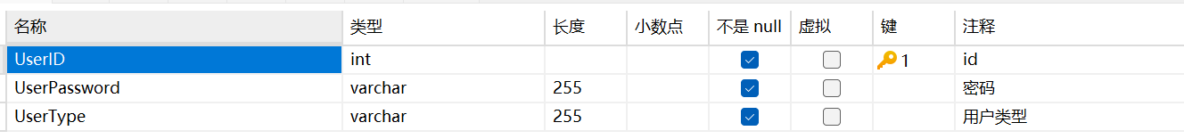

OrdinaryUser类
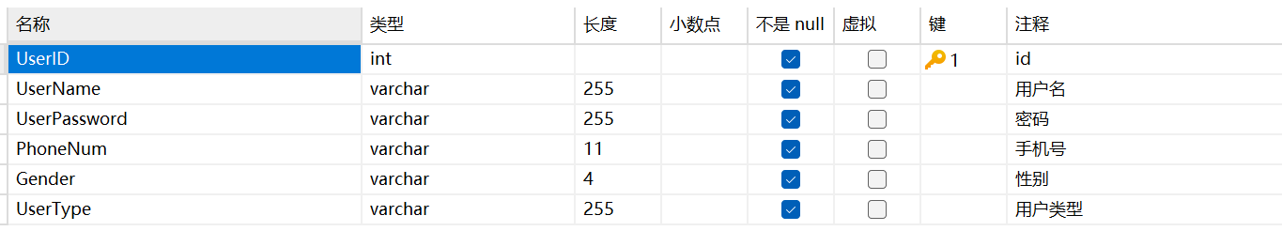

Administrator类
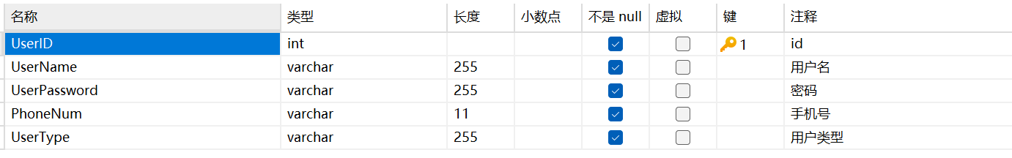

StadiumAdministrator类
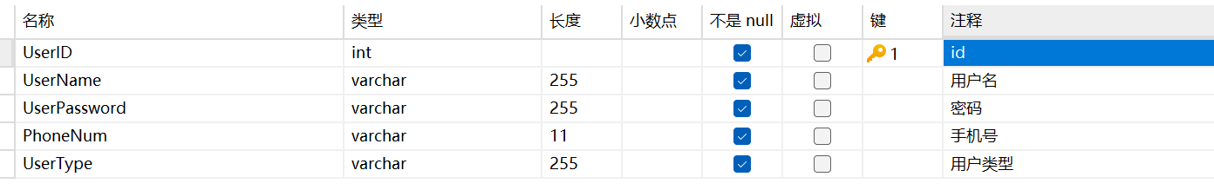

Stadium类
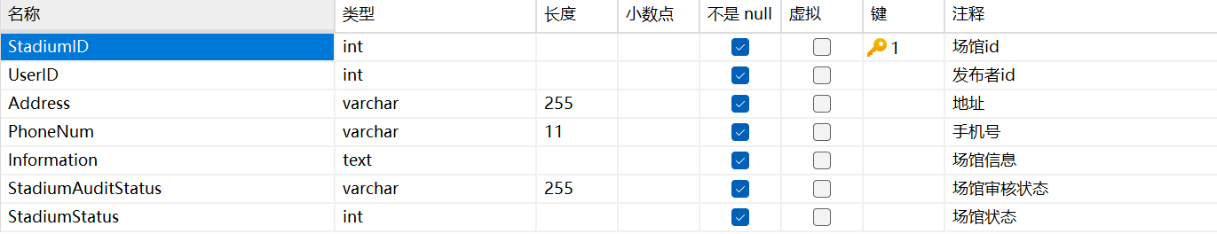

Field类
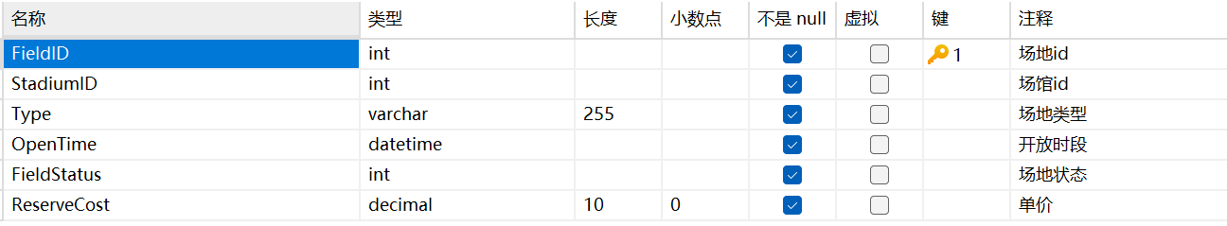

Period类
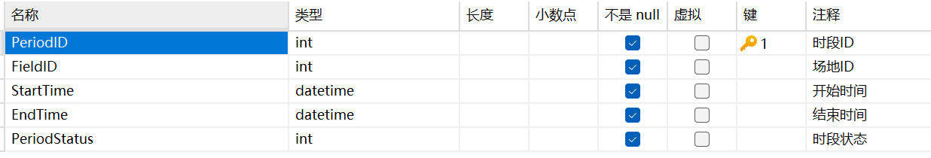

reservation类
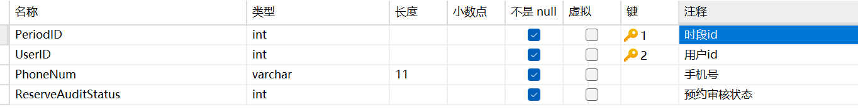
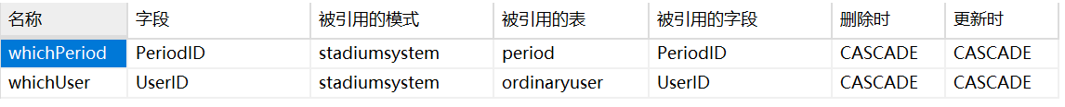

Comment类